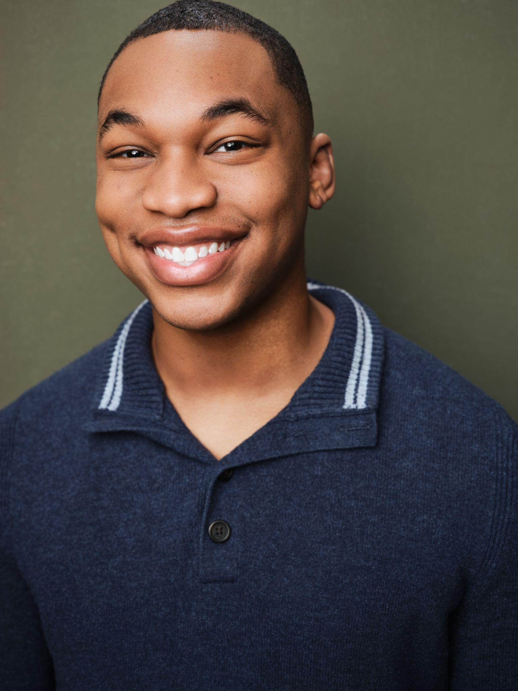
Michael Reed
He/Him Baritenor 5’10
Michaellandonreed21@gmail.com (601)-955-4245
Theatre:
Little Shop of Horrors Audrey II Coeur D’Alene Summer Theatre ` dir. Roger Welch
Little Shop of Horrors Audrey II Tibbits Opera House
dir. Brian Sage
Spelling Bee Mitch Mahoney Tibbits Opera House
dir. Marryn Barney & Brenda Sparks
Rent Benny Tibbits Opera House
dir. Brian Sage
Kinky Boots Angel/ U.S. Lola Duluth Playhouse
dir. Phillip Fazio
Forever Plaid Sparky Tibbits Opera House
dir. David Craven
Love’s Labour’s Lost Musical The King Penn State Centre Stage
dir. Christine O’Grady
Sweeney Todd Ensemble/U.S. Sweeney Penn State Centre Stage
dir. Zach Steele
Urinetown Dr. Billeaux Penn State Centre Stage
dir. David Kersnar
Hit the Wall Carson Penn State Centre Stage
dir. Robert Schneider
Crazy For You Sam (Cowboy Trio) Penn State Centre Stage
dir. Christine O’Grady
New Works and Concerts:
The Wetsuitman Lead Composer: Anne Van Steenwinkle
Centralia Lead Book/Lyrics, Music: Adam Chander-Berat, Julian Hornick
Halftime Show Ensemble Penn State vs Michigan Game
Education/Training
BFA Penn State University Musical Theatre Class of 2026
Voice: Dr. Gabriella Sam, Darnell T. Roulhac, Peter Infanger
Acting: Wendell Franklin, John Simpkins, Steve Snyder, Christine O’Grady Roberts
Dance: Natalie Malotke, Michele Dunleavy, A. Kikora Franklin, Linda Bowen
Special Skills:
Intermediate Sight Reading, Perfect Pitch, Beginner Piano, Bassoonist, Alto-Saxophone, Dialects: MLE, RP

